WEEK-08-SORTING ALORITHMS -BUBBLE AND SELECTION

CODING

REG NO;241801289

NAME:TAMILSELVAN.K

Q1

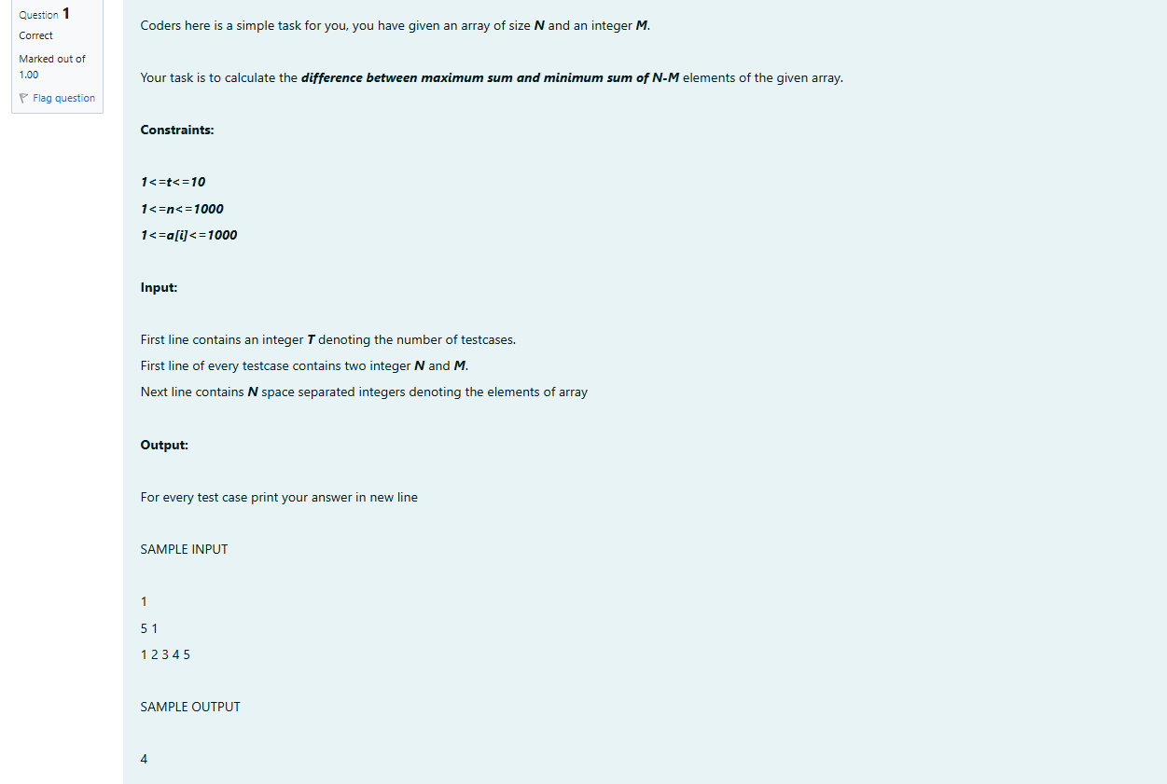

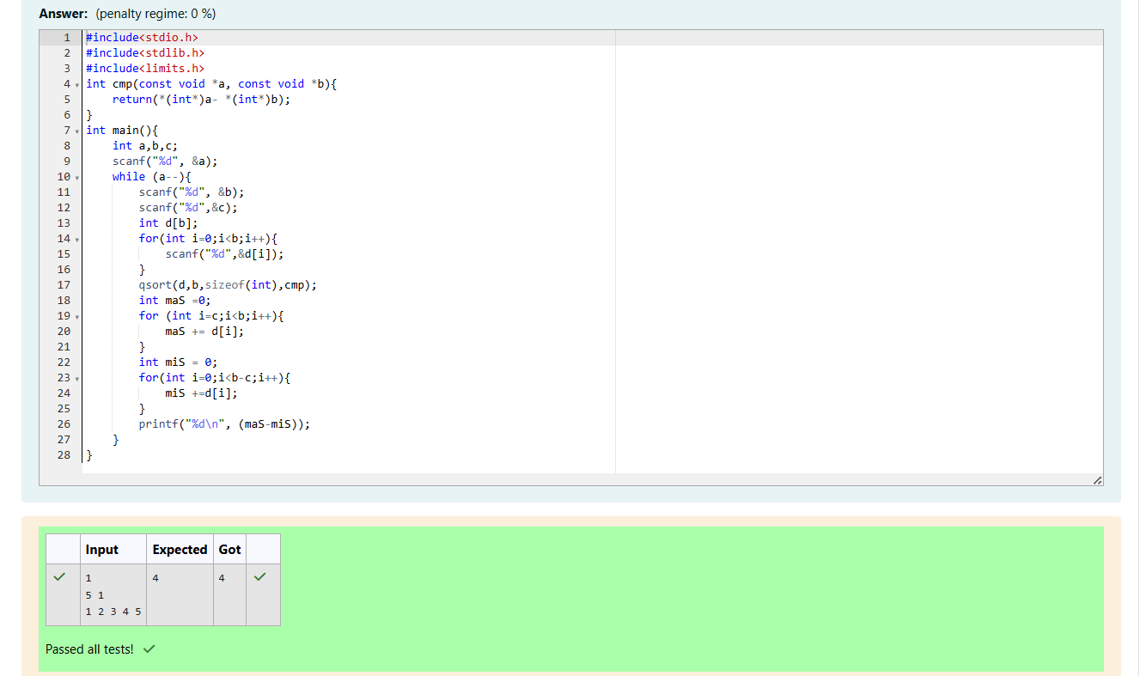

CODING

REG NO;241801289

NAME:TAMILSELVAN.K

Q2

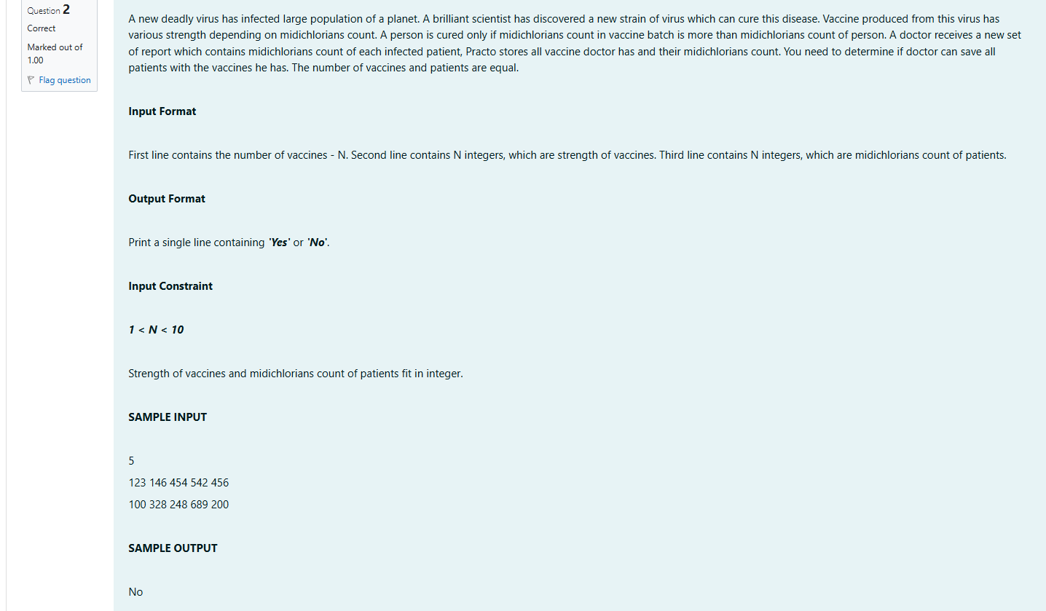

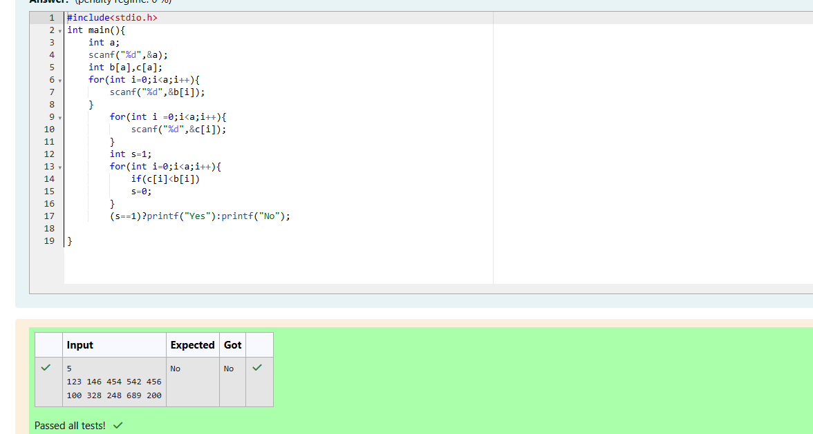

CODING

REG NO;241801289

NAME:TAMILSELVAN.K

Q3

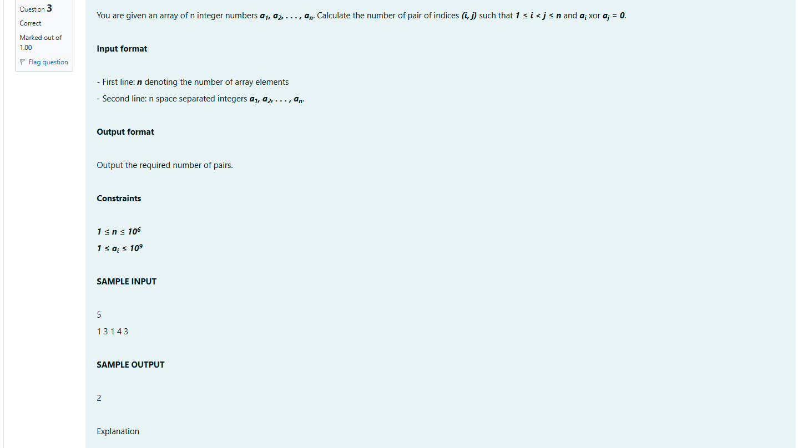

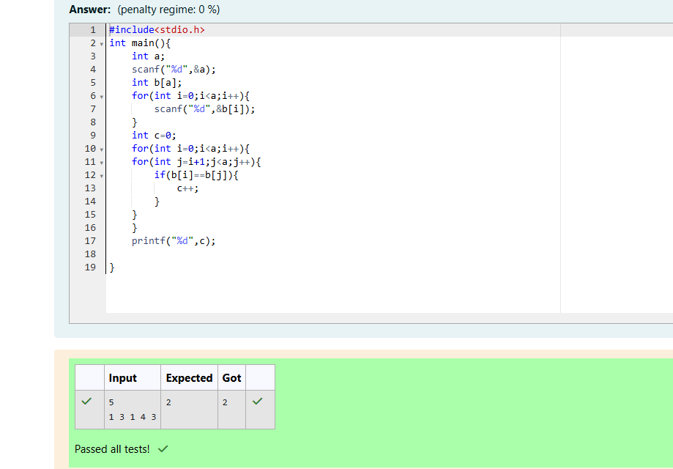

CODING

REG NO;241801289

NAME:TAMILSELVAN.K

Q4

